Airline Schedules

**Initial View**

**AirlineCode(PK),** AirlineName, (FlightCode, FlightNumber, FlightDate, DepartureAirportID, DepartureAirportName, DepartureTime, ArrivalAirportID, ArrivalAirportName, ArrivalTime, Cancelled, Full)

**1 NF**

**AirlineCode(PK),** AirlineName

**FlightCode(PK),** FlightNumber, FlightDate, DepartureAirportID, DepartureAirportName, DepartureTime, ArrivalAirportID, ArrivalAirportName, ArrivalTime, Cancelled, Full, *AirlineCode(FK)*

**2 NF**

**AirlineCode(PK),** AirlineName

**FlightCode(PK)**, FlightNumber, FlightDate, DepartureAirportID, DepartureAirportName, DepartureTime, ArrivalAirportID, ArrivalAirportName, ArrivalTime, Cancelled, Full, *AirlineCode(FK)*

**3 NF**

**AirlineCode(PK),** AirlineName

**FlightCode(PK),** FlightNumber, FlightDate, *DepartureAirportID(FK),* DepartureTime*, ArrivalAirportID(FK),* ArrivalTime, Cancelled, Full, *AirlineCode(FK)*

**DepartureAirportID(PK),** DepartureAirportName

**ArrivalAirportID(PK)**, ArrivalAirportName

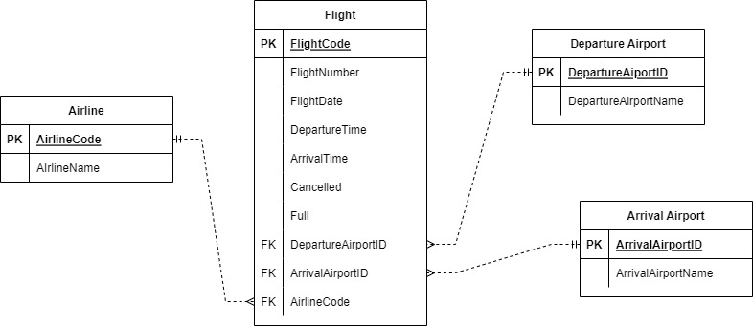

Airports

**Initial View**

**AirportID(PK),** City, Country, AirportName, IATA, ICAO, Latitude, Longitude, Altitude, Timezone, TzDatabaseTimeZone

**1 NF**

**AirportID(PK),** City, Country, AirportName, IATA, ICAO, Latitude, Longitude, Altitude, Timezone, TzDatabaseTimeZone

**2 NF**

**AirportID(PK),** City, Country, AirportName, IATA, ICAO, Latitude, Longitude, Altitude, Timezone, TzDatabaseTimeZone

**3 NF**

**AirportID(PK)**, City, Country, AirportName, IATA, ICAO, Latitude, Longitude, Altitude, Timezone, TzDatabaseTimeZone

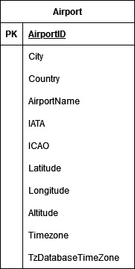

Booking a Flight

**Initial View**

**TicketConfirmationNumber(PK),** (PassengerNumber, PassengerName, PassengerPhoneNumber, PassengerAddress, PassengerCity, PassengerProvince, PassengerCountry, PassengerEmail, PassengerBirthdate,) PaymentAmount, PaymentMethod, PaymentConfirmationNumber, PaymentDate, FlightCode, FlightNumber, FlightName, FlightType, FlightDuration, FlightDate, DepartureTime, DepartureCode, ArrivalTime, ArrivalCode

**1 NF**

**TicketConfirmationNumber(PK),** PaymentAmount, PaymentMethod, PaymentConfirmationNumber, PaymentDate, FlightCode, FlightNumber, FlightName, FlightType, FlightDuration, FlightDate, DepartureTime, DepartureCode, ArrivalTime, ArrivalCode

**PassengerNumber(PK**), PassengerFirstName, PassengerLastName, PassengerPhoneNumber, PassengerAddress, PassengerCity, PassengerProvince, PassengerCountry, PassengerEmail, PassengerBirthdate, ***TicketConfirmationNumber(FK)(PK)***

**2 NF**

**TicketConfirmationNumber(PK),** PaymentAmount, PaymentMethod, PaymentConfirmationNumber, PaymentDate, FlightCode, FlightNumber, FlightName, FlightType, FlightDuration, FlightDate, DepartureTime, DepartureCode, ArrivalTime, ArrivalCode

**PassengerNumber(PK)**, PassengerFirstName, PassengerLastName, PassengerPhoneNumber, PassengerAddress, PassengerCity, PassengerProvince, PassengerCountry, PassengerEmail, PassengerBirthdate, ***TicketConfirmationNumber(FK)(PK)***

**3 NF**

**TicketConfirmationNumber(PK*)****, PaymentConfirmationNumber(FK), FlightCode(FK),*

**PaymentConfirmationNumber(PK),** PaymentDate, PaymentAmount, PaymentMethod,

**FlightCode(PK),** FlightNumber, FlightName, FlightType, FlightDuration, FlightDate, , *ArrivalAirportID(FK), DepartureAirportID(FK)*, DepartureTime, ArrivalTime

**DepartureAirportID(PK)**, DepartureCode

**ArrivalAirportID(PK),** ArrivalCode

**PassengerNumber(PK),** PassengerFirstName, PassengerLastName, PassengerPhoneNumber, PassengerAddress, PassengerCity, PassengerProvince, PassengerCountry, PassengerEmail, PassengerBirthdate, ***TicketConfirmationNumber(FK)(PK)***

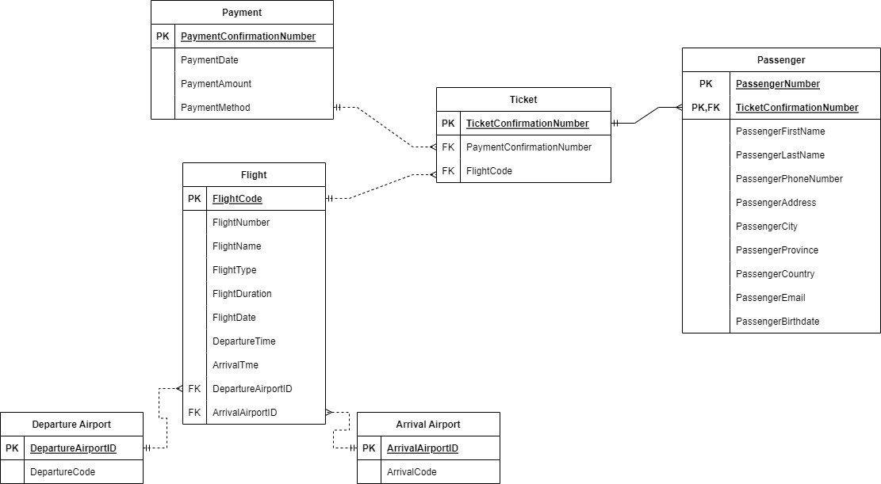

**Merged View**

